TẬP ĐOÀN CÔNG NGHIÊP
VIỄN THÔNG-QUÂN ĐỘI
VIETTEL



DESIGN SPECIFICATION

MODEL

ADDER WRAPPER



Author: Huan Nguyen-Duy
Date: 8/23/2024

CATALOG
1. OVERVIEW 4
2. ARCHITECTURE 5
3. SEQUENCE DIAGRAM 6
4. ACTIVITY DIAGRAM 7
4.1. Nb_transport_fw 8
4.2. Output_handling 9

FIGURE
Figure 1 : Adder wrapper architecture 5
Figure 2 : Sequence diagram 6
Figure 3 : nb_transport_fw flow diagram 8
Figure 4 output_handling activity diagram 9

TABLE
Error! No table of figures entries found.

OVERVIEW
This document illustrates detail design of wrapper adder 4 bits model using systemC. The adder 4 bits module is worte by verilog that is converted to systemC interface using tool v2sc, it is provided by Mazdak and Alborz authors.

Link tool v2sc
:: V2SC Product :: (mazdak-alborz.com)

ARCHITECTURE
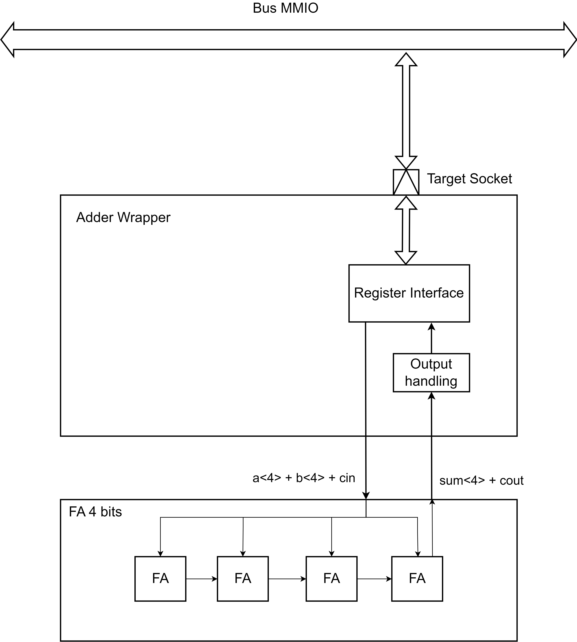
Figure 1: Adder wrapper architecture

The fig 1 shows detail design of adder wrapper model. The in/out registers are mapped into register interface. It can be accessed by a TLM socket.

SEQUENCE DIAGRAM
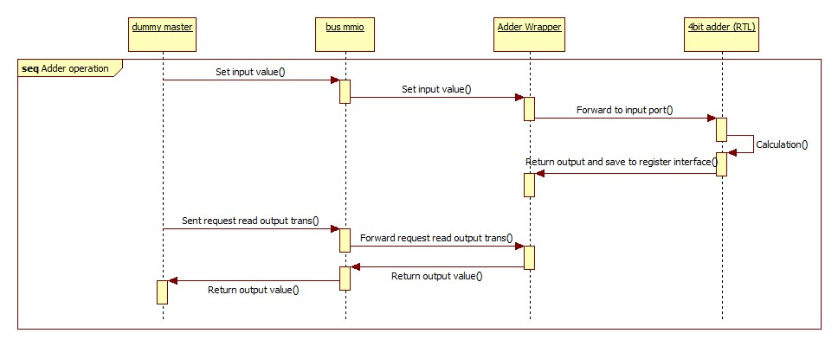
Figure 2: Sequence diagram

The adder wrapper supports read and write register through tlm target socket interface. All input and output ports are mapped into register interface that can be accessed by read or write register with specific address.

ACTIVITY DIAGRAM
In this chapter, the document provides all important activity digram of adder wrapper model.

Nb_transport_fw
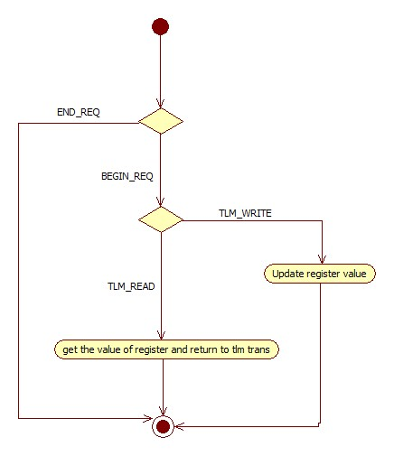
Figure 3: nb_transport_fw flow diagram

This function is called when the target socket receives data from bus. In this function, depending on TLM read or write command, the counter wrapper model assigns value to the corresponding register or reads value from the corresponding register, retuning this value to master.

Output_handling

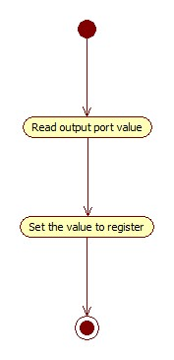
Figure 4output_handling activity diagram

The output_handling function is used to synchronize the output ports and reg ports of counter module with output port of the counter wrapper model and its register interface.

